Software Requirement Specifications
IUB Smart Portal



Submitted by
Musfirah BIBI
F22BINFT1M01147
Submitted to
Ms.Kianat

Department of Information Technology
Faculty of Computing
The Islamia University of Bahawalpur

Summery
The Software Requirements Specification (SRS) describes the design and functional scope of the IUB Smart Portal, a unified web-based academic management platform. The system aims to eliminate scattered platforms by integrating attendance, results, course content, announcements, and feedback features under one centralized solution. It supports three user roles—Admin, Faculty, and Student—each with personalized dashboards and controlled access. The portal ensures secure user authentication through encrypted credentials and role-based authorization. Teachers can upload assignments, post announcements, and mark student attendance efficiently. Students can access attendance records, course materials, event schedules, and academic results from a single dedicated interface. Administrators control user accounts, departmental structures, courses, and system configurations. The system is developed using HTML, CSS, JavaScript, Node.js, and MongoDB, making it scalable and web-friendly. It follows agile development principles for incremental improvement. The solution ensures fast response time, data reliability, and availability with daily database backups. The interface is designed to be responsive, supporting both desktop and mobile users. Non-functional requirements emphasize performance, usability, maintainability, and portability. Future enhancements include an integrated fee payment module, real-time chat, AI-based analytics, and a mobile application version. Overall, the IUB Smart Portal significantly enhances communication, transparency, academic record management, and access to institutional services.

Table of Contents
Table of Contents

1. Introduction
1.1 Purpose
1.2 Document Conventions
1.3 Intended Audience
1.4 Product Scope
1.5 References

2. Overall Description
2.1 Product Perspective
2.2 Product Features Summary
2.3 User Classes and Characteristics
2.4 Operating Environment
2.5 Constraints
2.6 Assumptions & Dependencies

3. System Features
3.1 User Authentication
3.1.1 Description
3.1.2 Functional Requirements
3.2 Dashboard Feature
3.2.1 Functional Requirements
3.3 Attendance Management
3.3.1 Functional Requirements
3.4 Academic Result Management
3.4.1 Functional Requirements
3.5 Course Content & Assignments
3.5.1 Functional Requirements
3.6 Announcements & Notifications
3.7 Event Management Module
3.8 Feedback Submission

4. Non-Functional Requirements
4.1 Performance Requirements
4.2 Security Requirements
4.3 Usability Requirements
4.4 Reliability Requirements
4.5 Maintainability Requirements
4.6 Portability Requirements

5. System Models
5.1 Use Case Diagram
5.2 Data Flow Diagrams
5.2.1 Level-0 DFD
5.2.2 Level-1 DFD
5.3 ER Diagram

6. Database Design
6.1 Entity Description
6.2 Sample Table Structure
6.2.1 Student Table
6.2.2 Attendance Table
6.2.3 Result Table

7. Interface Requirements
7.1 Login Interface
7.2 Student Interface
7.3 Teacher Interface
7.4 Admin Interface

8. Future Enhancements

9. Conclusion
10.

1. Introduction
1.1 Purpose
The purpose of this Software Requirements Specification (SRS) document is to define the functional and non-functional requirements for the development of the IUB Smart Portal. This system aims to provide an integrated digital platform for students, faculty, and administration of The Islamia University of Bahawalpur. The SRS ensures that the system requirements are clear to all stakeholders including developers, project managers, testers, and institutional administrators.
The document serves as a reference point throughout development, to confirm that the final product aligns with defined requirements. Additionally, it outlines constraints, dependencies, system features, and performance expectations of the project.

1.2 Document Conventions
This document follows IEEE SRS standards and contains structured information categorized by functional sections.
The font used is Times New Roman, size 12, and headings follow hierarchical numbering (1.0, 1.1, 1.1.1 etc.).

1.3 Intended Audience
The document is intended for:
Development team: responsible for implementation
Quality assurance and testing team
Project supervisor and faculty body
Stakeholders from university administration
UI/UX designers
Future maintainers of the system

1.4 Product Scope
The IUB Smart Portal is designed to:
Provide a unified digital platform for student-faculty communication
Manage attendance, results, course materials and announcements
Facilitate teacher-based uploads like assignments, notices, grades
Provide dashboards based on roles (Admin, Faculty, Student)
Enhance accessibility to institutional data
Maintain updates regarding events, seminars, notifications
This product will improve efficiency, minimize duplication of systems, reduce confusion between multiple platforms, and enhance transparency and accessibility.

1.5 References
University academic policies
IEEE SRS Standard Documentation
MongoDB official documentation
Node.js official documentation

2. Overall Description

2.1 Product Perspective
The IUB Smart Portal is a fresh web-based system replacing multiple existing platforms currently used by the institution. The system integrates all core functionalities into a single place.
The portal will have:
✔ Web-based interface
✔ Role-based authentication
✔ Dynamic dashboards
✔ Data tracking modules
All user interactions will be facilitated through a centralized database.

2.2 Product Features Summary

Feature Description
Login & Authentication Secure login with differentiated roles
Dashboard Display user-specific information
Attendance Management Teachers update attendance, students view records
Material Sharing Assignments, notices & course notes upload
Result Portal View semester-wise results, CGPA & grades
Event Management Schedule, publish & notify events
Feedback System Students submit feedback
Admin Management Admin controls users, courses, and roles

2.3 User Classes and Characteristics

User Type Description
Admin Complete access to system modules & settings
Teacher Updates attendance, results, assignments, notices
Student Views results, attendance, calendar & notifications

2.4 Operating Environment
Frontend: HTML, CSS, JavaScript
Backend: Node.js (Express.js)
Database: MongoDB
Development Environment: VS Code
Deployment Hosting: Vercel / Render / MongoDB Atlas
Browser Compatibility: Chrome, Firefox, Edge

2.5 Constraints
Only registered university personnel are allowed access
Active internet connectivity is required
Limited initial hardware resources for hosting
Responsiveness required on both mobile and desktop
Server downtime may affect accessibility

2.6 Assumptions & Dependencies
Users have basic computer literacy
Internet and device access
Data shared by faculty is accurate

3. System Features
3.1 User Authentication
Description
Secure access based on three user roles.

Functional Requirements
FR-1: Users must log in using a valid username & password
FR-2: System should display dashboards based on role
FR-3: Password should be encrypted

3.2 Dashboard Feature
Functional Requirements
FR-4: Students can view attendance, results, courses
FR-5: Teachers can see assigned subjects
FR-6: Admin can view user statistics

3.3 Attendance Management
Functional Requirements
FR-7: Faculty can mark attendance with date-wise selection
FR-8: Students must view attendance status per course

Output
Monthly view
Percentage summary

3.4 Academic Result Section
Functional Requirements
FR-9: Teacher uploads marks & grades
FR-10: Student views past results

3.5 Course Content & Assignments
Functional Requirements
FR-11: Teacher uploads PDF, doc files, or links
FR-12: Students download learning content

3.6 Announcements & Notifications
FR-13: Teacher can publish course announcements
FR-14: Students get real-time notifications

3.7 Event Panel
Functionalities:
✔ University-wide events
✔ Department-wise schedules
✔ Notification update

3.8 Feedback Submission
FR-15: Students submit structured feedback
FR-16: Admin exports feedback summary

4. Non-Functional Requirements
4.1 Performance Requirements
Application must support minimum 500+ users concurrently
Page load must be < 3 seconds
Database queries should respond within 2 seconds

4.2 Security Requirements
User passwords must be encrypted
HTTPS protocol required
Role-based authorization

4.3 Usability Requirements
Responsive interface
Mobile-first UI design
Intuitive navigation panel

4.4 Reliability Requirements
System uptime expected ≥ 96%
Backup taken daily automatically

4.5 Maintainability Requirements
Code must follow modular structure
API based communication recommended

4.6 Portability Requirements
Must run across Android & Windows browsers
Compatible on desktops, tablets and mobile phones

5. System Models
5.1 Use Case Diagram
Actors:
✔ Student
✔ Faculty
✔ Admin

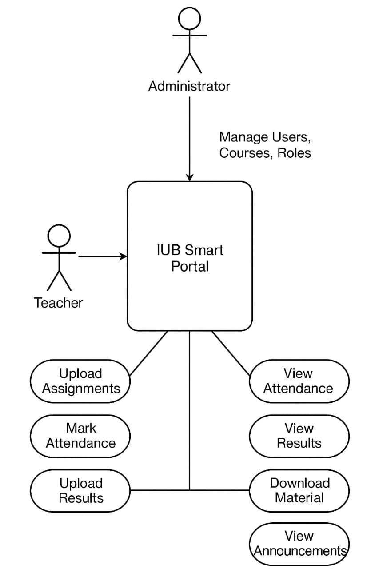
Fig 5.1 interaction between actors and system
5.2 Data Flow Diagram
Level-0
Login → Dashboard → Module Access → Output
Level-1
Students access modules
Teachers input updates
Admin manages system
5.3 ER Diagram Entities
Student
Teacher
Admin
Result
Course
Attendance
Assignments
Notification

6. Database Design
Student Table

Field Type
student_id varchar
name text
department text
email text

Attendance Table
Field Type
attendance_id varchar
student_id varchar
course_id varchar
status int
7. Interface Requirements

Login Page
Input fields for email/password
Forgot password option

Student Interface
Attendance view
Result view

Teacher Interface
Upload assignment
Mark attendance

Admin Console
User control
Course management

8. Future Enhancements
Integration of fee payment gateway
AI-based attendance prediction
Mobile application for Android/iOS
Push notification support
Real-time chat feature

9. Conclusion
The IUB Smart Portal SRS defines key requirements ensuring a user-friendly, unified digital platform for the university. Once implemented, it will significantly improve communication, transparency, accessibility, and academic management within IUB.

